ANALYSTLAB AFRICA
INTERNSHIP
CHINOOK MUSIC DATABASE
SQL QUERY ANALYSIS REPORT
Week 3 Deliverable

Prepared by
Akhimien Evelyn Ilobekemen
June 2026

Table of Contents
Table of Contents 1
1. Introduction 1
2. Database Overview 1
3. Query Tasks and Results 1
Task 1: Total Number of Customers 1
Task 2: Total Number of Artists 1
Task 3: Total Number of Genres 1
Task 4: List of All Artists 1
Task 5: Albums by a Specific Artist (Queen) 1
Task 6: Tracks in a Specific Album 1
Task 7: Total Number of Tracks per Genre 1
Task 8: Top 10 Customers by Total Spending 1
Task 9: Invoices for a Specific Customer (John) 1
Task 10: Tracks by a Particular Composer (AC/DC) 1
Task 11: Average Track Duration per Album 1
Task 12: Customers Who Have Not Made Any Purchases 1
Task 13: Most Expensive Track in the Database 1
4. Summary of Key Findings 1
5. Conclusion 1

1. Introduction
This report documents the Structured Query Language (SQL) analysis carried out in Week 3 of the AnalystLab Africa internship, using the Chinook sample database. The Chinook database models a digital media store and contains tables for artists, albums, tracks, genres, media types, customers, and invoices.
The objective of this exercise was to practice writing SQL queries that answer realistic business questions — ranging from simple row counts to multi-table joins, aggregations, and outer joins — and to interpret the results in a way that supports data-driven decision making.
Each task below presents the business question, the SQL query used to answer it, a screenshot of the query output, and a short insight describing what the result tells us about the Chinook store's data.

2. Database Overview
Before running analytical queries, the MediaType table was inspected to understand the digital formats available in the store.
SQL Query
SELECT *
FROM MediaType;
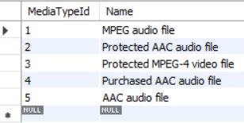
Figure 1: All records in the MediaType table
Insight: The store offers five distinct media formats, including standard MPEG audio, protected and unprotected AAC audio, and a protected MPEG-4 video format — showing the catalogue spans both audio and video content.

3. Query Tasks and Results

Task 1: Total Number of Customers
Business Question
How many customers are currently registered in the store?
SQL Query
SELECT COUNT(CustomerId) AS total_customer
FROM Customer;

Figure 2: Total customer count
Insight: The Chinook store has 59 registered customers, giving a manageable base for customer-level analysis such as spending and segmentation.

Task 2: Total Number of Artists
Business Question
How many unique artists are represented in the catalogue?
SQL Query
SELECT COUNT(ArtistId) AS total_artist
FROM Artist;

Figure 3: Total artist count
Insight: The catalogue features 275 artists, reflecting a fairly diverse music library rather than a catalogue dominated by a small number of acts.

Task 3: Total Number of Genres
Business Question
How many music/video genres are tracked in the store?
SQL Query
SELECT COUNT(GenreId) AS total_genre
FROM Genre;

Figure 4: Total genre count
Insight: 25 genres are catalogued, spanning a wide creative range — from Rock and Latin to TV Shows and Drama — which suggests the platform serves both music and screen-content audiences.

Task 4: List of All Artists
Business Question
What are the IDs and names of artists in the database?
SQL Query
SELECT ArtistId, Name
FROM Artist;
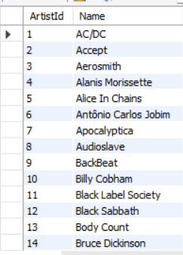
Figure 5: Sample of artist records (first 14 rows)
Insight: The result confirms each artist has a unique ArtistId, which is the key used to link artists to their albums in later queries.

Task 5: Albums by a Specific Artist (Queen)
Business Question
Which albums in the store belong to the artist Queen?
SQL Query — Approach 1: Subquery
SELECT AlbumId, Title
FROM Album
WHERE ArtistId = (
SELECT ArtistId FROM Artist WHERE Name = 'Queen'
);
SQL Query — Approach 2: JOIN
SELECT a.AlbumId, a.Title
FROM Album a
JOIN Artist ar ON a.ArtistId = ar.ArtistId
WHERE ar.Name = 'Queen';
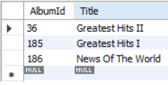
Figure 6: Albums by Queen — identical result from both approaches
Insight: Both the subquery and JOIN approaches return the same three albums (Greatest Hits I, Greatest Hits II, and News of the World), confirming that a JOIN is a readable and equally valid alternative to a nested subquery when filtering by a related table's attribute.

Task 6: Tracks in a Specific Album
Business Question
Which tracks belong to the album “For Those About To Rock We Salute You”?
SQL Query
SELECT t.TrackId, t.Name, t.Composer, t.UnitPrice
FROM Track t
JOIN Album al ON t.AlbumId = al.AlbumId
WHERE al.Title = 'For Those About To Rock We Salute You';
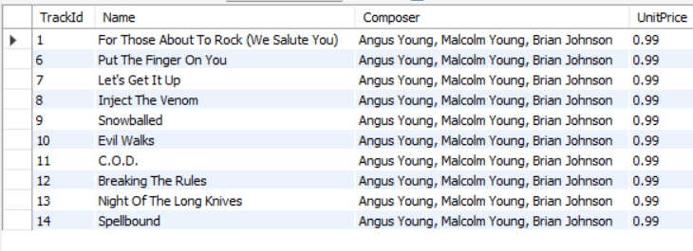
Figure 7: Tracks on the album, with composer and unit price
Insight: All ten tracks on this AC/DC album are priced uniformly at $0.99, and most were composed by the trio of Angus Young, Malcolm Young, and Brian Johnson — typical of the band's classic songwriting credits.

Task 7: Total Number of Tracks per Genre
Business Question
How are tracks distributed across genres, from most to least?
SQL Query
SELECT g.Name AS GenreName, COUNT(t.TrackId) AS NumberOfTracks
FROM Genre g
JOIN Track t ON g.GenreId = t.GenreId
GROUP BY g.Name
ORDER BY NumberOfTracks DESC;
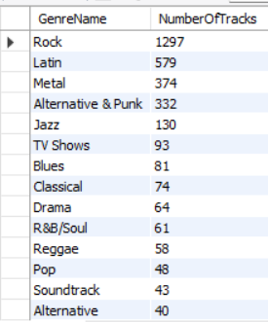
Figure 8: Track count by genre, ranked highest to lowest
Insight: Rock dominates the catalogue with 1,297 tracks — more than double the next genre (Latin, 579) — indicating Rock is the core content category and a natural focus area for marketing or recommendation features.

Task 8: Top 10 Customers by Total Spending
Business Question
Who are the highest-value customers by total invoice spending?
SQL Query
SELECT c.FirstName, c.LastName, SUM(i.Total) AS TotalSpending
FROM Customer c
JOIN Invoice i ON c.CustomerId = i.CustomerId
GROUP BY c.CustomerId, c.FirstName, c.LastName
ORDER BY TotalSpending DESC
LIMIT 10;
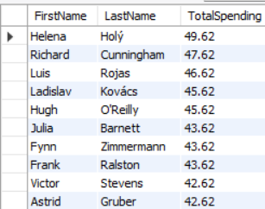
Figure 9: Top 10 customers ranked by total spending
Insight: Helena Holý is the top spender at $49.62, with spending across the top 10 customers clustered fairly closely between roughly $42 and $50 — suggesting no single customer dominates revenue, which is a healthy sign for the business's customer concentration risk.

Task 9: Invoices for a Specific Customer (John)
Business Question
What invoices were generated for customers with the first name John?
SQL Query
SELECT i.InvoiceId, i.InvoiceDate, i.Total
FROM Invoice i
JOIN Customer c ON i.CustomerId = c.CustomerId
WHERE c.FirstName = 'John';
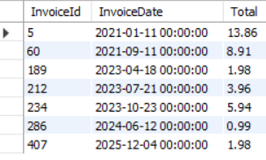
Figure 10: Invoices linked to customer John
Insight: The customer named John has multiple invoices spanning from 2021 through 2025, with individual invoice totals ranging from under $2 to nearly $14, reflecting irregular, low-to-moderate purchase activity over several years.

Task 10: Tracks by a Particular Composer (AC/DC)
Business Question
Which tracks have AC/DC credited as the composer?
SQL Query
SELECT t.Name AS TrackName, t.Composer
FROM Track t
WHERE t.Composer LIKE '%AC/DC%';
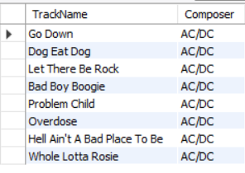
Figure 11: Tracks composed by AC/DC
Insight: The LIKE operator with wildcard matching successfully retrieves all tracks where 'AC/DC' appears anywhere in the Composer field, demonstrating pattern matching as a flexible alternative to exact-match filtering.

Task 11: Average Track Duration per Album
Business Question
Which albums have the longest average track duration?
SQL Query
SELECT al.Title AS AlbumTitle, AVG(t.Milliseconds) AS AverageDurationMs
FROM Album al
JOIN Track t ON al.AlbumId = t.AlbumId
GROUP BY al.Title
ORDER BY AverageDurationMs DESC;
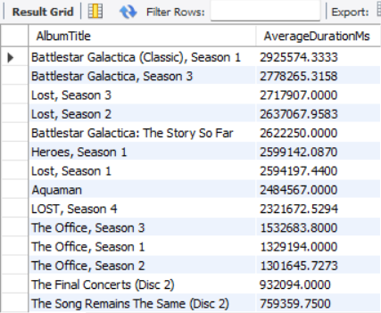
Figure 12: Albums ranked by average track duration (milliseconds)
Insight: TV and film soundtrack albums (e.g., Battlestar Galactica, Lost, Heroes) occupy the longest average track durations — each averaging 25–49 minutes per track — because these are essentially full episodes, not songs, while music albums such as The Office cluster lower despite still using the same schema.

Task 12: Customers Who Have Not Made Any Purchases
Business Question
Are there any customers who have never placed an order?
SQL Query
SELECT c.FirstName, c.LastName, c.Email
FROM Customer c
LEFT JOIN Invoice i ON c.CustomerId = i.CustomerId
WHERE i.InvoiceId IS NULL;

Figure 13: Result set — no matching rows returned
Insight: The query returns zero rows, meaning every customer in the database has at least one invoice on record. This is a useful data-quality finding: the LEFT JOIN with an IS NULL filter is the standard pattern for finding 'orphan' parent records, and here it confirms full customer engagement with no inactive accounts.

Task 13: Most Expensive Track in the Database
Business Question
Which single track has the highest unit price in the entire catalogue?
SQL Query
SELECT Name AS TrackName, UnitPrice
FROM Track
ORDER BY UnitPrice DESC
LIMIT 1;

Figure 14: Highest-priced track in the catalogue
Insight: “Battlestar Galactica: The Story So Far” is priced at $1.99 — roughly double the standard $0.99 track price — consistent with it being a long-form video/TV item rather than a standard music track, reinforcing the duration pattern seen in Task 11.

4. Summary of Key Findings
- The store holds 59 customers, 275 artists, and 25 genres, giving a moderately sized but diverse catalogue to analyze.
- Rock is by far the dominant genre (1,297 tracks), more than double the second-place genre, Latin (579 tracks).
- Top customer spending is fairly evenly spread across the top 10 customers (roughly $42–$50 each), with no single customer dominating revenue.
- Every customer in the database has placed at least one order — the LEFT JOIN check for non-purchasing customers returned no results.
- TV/film soundtrack albums have far longer average track durations than music albums, and this same content also carries the highest unit price ($1.99 vs. the standard $0.99), showing pricing is tied to content length and type.
- JOIN and subquery approaches were shown to produce identical results when filtering by a related table's attribute, reinforcing that query approach can be chosen based on readability without changing correctness.

5. Conclusion
This exercise reinforced core SQL skills required for data analysis: aggregate functions (COUNT, AVG, SUM), filtering with WHERE and LIKE, table joins (INNER and LEFT JOIN), grouping and ordering results, and limiting result sets. Beyond syntax, each query was tied back to a business question and interpreted for what it reveals about the Chinook store's catalogue, customers, and revenue — a workflow that mirrors how SQL is used in real analytics roles.

